PROJECT PROPOSAL (SYNOPSIS)

INDIRA GANDHI NATIONAL OPEN UNIVERSITY

BCSP-064

ON

E-LEARNING MANAGEMENT SYSTEM

By

Aman Tiwari (186407279)

UNDER GUIDANCE

OF

Mr. Mukesh Aarya

Submitted to the Shyamlal College (0769) in

Partial fulfilment of the Requirements for the degree of

Bachelor

Of

Computer Applications



Indira Gandhi National Open University

MaidanGarhi

New Delhi-110068

Table of Content

|  |  |  |
| --- | --- | --- |
| S.NO. | CONTENT | PAGE NO. |
| 1. | Title of the Project |  |
| 2. | Introduction and Objectives of the Project |  |
| 3. | Project Category |  |
| 4. | Analysis |  |
| 5. | A complete structure |  |
| 6. | Tools / Platform, Hardware and Software Requirement specifications |  |
| 7. | Are you doing this project for any Industry/Client? |  |
| 8. | Future scope and further enhancement of the project. |  |

1. Title of Project

E-Learning Management System



2.1 Introduction of the Project

The "E-learning Management System" has been developed to override the problems prevailing in the practicing manual system. This software is supported to eliminate and in some cases reduce the hardships faced by this existing system. Moreover this system is designed for the particular need of the company to carry out operations in a smooth and effective manner.

The application is reduced as much as possible to avoid errors while entering the data. It also provides error message while entering invalid data. No formal knowledge is needed for the user to use this system. Thus by this all it proves it is user-friendly. E- Learning Management System, as described above, can lead to error free, secure, reliable and fast management system. It can assist the user to concentrate on their other activities rather to concentrate on the record keeping. Thus it will help organization in better utilization of resources.

Every organization, whether big or small, has challenges to overcome and managing the information of Student, Assignment, QUIZ, CLASS, and QUESTION. Every E-learning Management System has different Assignment needs, therefore we design exclusive employee management systems that are adapted to your managerial requirements. This is designed to assist in strategic planning, and will help you ensure that your organization is equipped with the right level of information and details for your future goals. Also, for those busy executive who are always on the go. These systems will ultimately allow you to better manage resources.

2.2 Objective of the Project

The main objective behind this project is to provide a user friendly environment to provide knowledge and give everyone a chance to learn, irrespective of where they are, provided they register themselves with the system.

The main features that the system provides can be made use of, once the registered people select their interested subject and take a starter test. This helps to establish incremental learning process. After taking this, based on their level of competence, they can take available tutorials, take online tests and also discuss an issue/topic by posting messages in the discussion forum. Along with this they can also take real time simulations of the most widely known competitive exams.

Project on E-learning Management System is to manage the details of Assignment, Student, TEACHER, QUIZ, and QUESTION. It manages all the information about Assignment, CLASS, QUESTION, and Assignment. The project is totally built at administrative end and thus only the administrator is guaranteed the access. The purpose of the project is to build an application program to reduce the manual work for managing the Assignment, Student, CLASS, and TEACHER. It tracks all the details about the TEACHER, QUIZ, and QUESTION.

3. Project Category: Web Based Application

This project is under category of **“LEARNING MANAGEMENT SYSTEM*”*.** This project aims to provide improved functionality and better user interactive environment. With **“HTML,CSS,JS,jQuery,BootStrap and AJAX”** as a front end and JSP, Servlet and MySQL as a back end, this project falls in the category of Relational Database Management System (RDBMS) project.

HTML provides a structure of our site while CSS provides styling and JS for validation and jQuery for slider and animations or bootstrap providing the responsiveness, moodles and etc. and AJAX providing the real-time Form validation these all are providing fully user interactive windows based environment that helps user to learn the system in a better way. While MySQL on the other hand, provides better functionality and effectiveness to the system while maintaining the database records. And JSP and Servlet act as a bridge between the front-end and the database. All the tables are being used in this project are inter-related and fully normalized, so this project “LEARNING MANAGEMENT SYSTEM” is a “Web Based Application Project” using Relational Database Management System (RDBMS).

**Hibernate** ORM (or simply **Hibernate**) is an object-relational mapping tool for the Java programming language is also used. It provides a framework for mapping an object-oriented domain model to a relational database. It generates SQL calls and relieves the developer from the manual handling and object conversion of the result set.

4. Analysis

5. A complete structure

5.3 PROCESS LOGIC FOR EACH MODULE

Planning and scheduling

**PROJECT CONTROL SYSTEMS:**

The purpose of controlling a project is to monitor the progress of the activities against the plans, to ensure that the goals are being approached and eventually achieved. Other aspects of control are to detect, as soon as possible, when deviations from the plan are occurring so that corrective action may be taken. Most project control techniques are based on breaking down the goal of the project into several Intermediate goals. Each Intermediate goal can turn be broken further. This process can be repeated until each goal can turn be broken further. This process can be repeated until each goal is small enough to be understood. We can plan for each goal individually – its resource requirements, assignments of responsibility, scheduling, etc.

Two general scheduling techniques are GANTT charts and PERT Charts as discussed below.

**GANTT CHART:**

A bar chart is perhaps the simplest form of formal project management. The bar chart also known as GANTT CHART is used almost exclusively for scheduling purpose and therefore controls only the time dimension of projects. Gantt chart is a project control technique that can be used for several purposes, including scheduling, budgeting and resource planning. A Gantt chart is a bar chart, with each bar representing an activity. The bars are drawn against a time line. The length of each bar is proportional to the length of time planned for the activity. Gantt chart can take different forms depending on their Intended use. They are best for resource scheduling. Gantt charts are useful for resource planning and scheduling. Gantt chart they show the tasks and their duration clearly. However they do not show Inter task dependencies plainly.

**PERT CHART:**

Unlike the bar chart, PERT can be both cost and a time management system PERT is organized by events and activities or tasks. PERT has several advantages over bar charts and is likely to be used with more complex projects. One advantage of PERT is that it is a scheduling device that also shows graphically which tasks must be completed before others are begun. PERT enable the calculation of a Critical path. Each path and cost associated with each task along a path is calculated, and the path that requires the greatest amount of elapsed time is the Critical path. Calculation of the critical path enables project manager to monitor this series of tasks more closely. PERT controls time and cost during the project the project and also facilities finding the right balance between completing a project on time and completing it within budget. PERT recognizes that projects are complex that some task must be completed before other can be started and that the appropriate way to manage a project is to be defined and control each task. Because projects often fall behind schedule, PERT is designed to facilitate getting back schedule. PERT is based in part on the premise that subjective estimates of the total completion time for a project are usually greatly inferior to the sum of subjective estimates for each task. The PERT chart gives a graphical representation of this information.

**Advantages of PERT**

* It forces the manager to plan.
* It shows an Interrelationship among the tasks in the project, in particular, clearly identifies the critical path of the project, thus helping to focus on it.
* It exposes all possible parallelism in the activities and thus helps in allocating resources.
* It allows scheduling and simulation of alternative schedule.
* It enables the manager to monitor and control the project.

Despite these advantages, PERT is just a tool, and its use does not automatically guarantee the success of the project. Gantt chart can be derived automatically from PERT charts.

The charts are shown in figure A (Gantt chart) and B (PERT Chart).

**GANTT CHART**

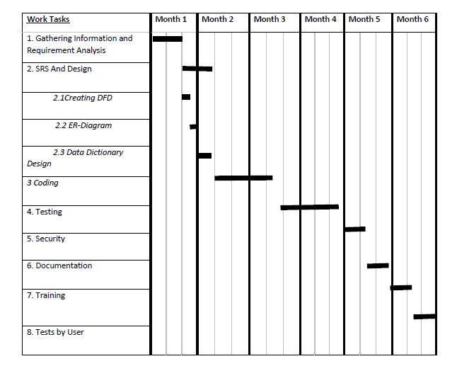

**Figure A:- GRANTT CHART**

PERT CHART

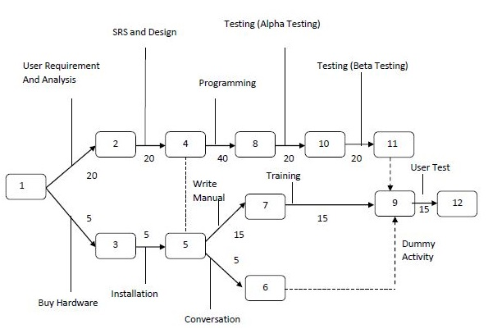

**Figure B:- PERT CHART**

SOFTWAR ENGINEERING APPROACH:

The field of software engineering is related to the development software in systematic manner unlike simple programs which can be developed in isolation and there may not be any systematic approach being followed. As there is large difference between programming and software engineering. As it provides models that lead to the production of well documented software in a manner that is predictable. For a mature process, it should be possible to determine in advance how much time and effort will be required to produce the final product. To develop successful software, I have to follow some models, which act as guidelines.

The model I have used is Waterfall Model or Classic Life Cycle. In this model first of all the existed system is observed. Then customer requirements are taken in consideration then planning, modelling, construction and finally deployment.

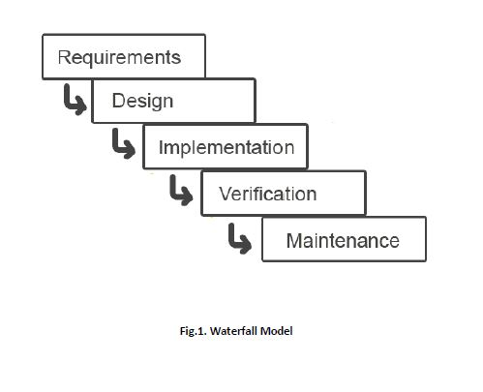

**Fig 1:- Waterfall Model**

SYSTEM DESIGN:

INTRODUCTION:

System design is the specification of a detailed computer-based solution. (Bentley, L, D., & Whitten, J, L (2008)) Also known as physical design.

There were many techniques or approaches that are concerning to the aspect of the machine design and can be categorized as follow:

Model-Driven Approaches

Rapid Application Development (RAD)

Joint Application Development (JAD)

5.4 TESTING AND DEBUGGING:

Testing is the process of executing the program with the intent of finding errors and it establishes confidence that the program does what it is supposed to do. It can be done in many ways:

*Unit Testing:* It is testing of individual module. Before initiating unit testing, it must be ensured that the code is peer previewed.

*Integration Testing:* It is performed after all the software units are combined together. The objective here is to test the software interfaces. Project team conducts the integration testing. Before entering integration testing, it may be ensured that code review and unit testing have been performed on the individual software modules.

System Testing: The software is compiled as product and then it is tested as a whole. This can be accomplished using one or more of the following tests:

* Functionality testing - Tests all functionalities of the software against the requirement.
* Performance testing - This test proves how efficient the software is. It tests the effectiveness and average time taken by the software to do desired task. Performance testing is done by means of load testing and stress testing where the software is put under high user and data load under various environment conditions.
* Security & Portability - These tests are done when the software is meant to work on various platforms and accessed by number of persons.
* Regression Testing: Whenever a software product is updated with new code, feature or functionality, it is tested thoroughly to detect if there is any negative impact of the added code. This is known as regression testing.

**5.5 REPORT GENERATION:**

Any project or program is required what input it is giving. It is the input, which matters the most and any managements, which is decided for computerization of pay bills for their organization. Spending some money on it does the project designing of the organization. So a cost analysis is also involved to see what benefits the organization can get out of the project.

The Input of the project **“ E-LEARNING MANAGEMENT SYSTEM** **”** has a Main Page containing the list of Different Forms i.e. admin/developer form, Teacher/faculty form, student form, login form, new user form, personal information form, reporting form, feedback form and many other forms. The Project also includes the Topic description of the Courses offered by Faculty/Admin and per course Fee/cost description, transaction report(s) of individual student and Teacher. The Current system has been made so versatile that any School/University/Organization can implement it.

Any project or program is required on what output it is giving. Output is compulsory for any organization for management to take the decision for computerization of their organization. Spending money on it, the organization needs in what respect the project can be benefited, which is possible by viewing the output. So a cost analysis is also involved to see what benefits the organization to give the output of the project.

The System has the facility to view different reports. It also contains the pages, which display the list of courses offered by our faculty/admin, their performances etc. which is the output of the project.

**6. TOOLS, SOFTWARE & HARDWARE REQUIREMENTS**

We have a wide range of options of languages. From these options we can choose appropriate platform/ tools and languages for development of the project. Some of these are as follows:-

Project Category: Web-Based Application

**SOFTWARE REQUIREMENTS:**

**IDE:** Eclipse oxygen or higher version

**Front End:** HTML, CSS, JavaScript, AJAX, Bootstrap, jQuery

**Programming Language:** JAVA

**Back End:** JSP, Servlet, Hibernate

**RDBMS:** MySQL 8.0 or Higher

**Server:** Apache Tomcat 8.0 or Higher

**Browser:** Chrome, Firefox etc. (latest version)

**Operating System:** Windows 7 and above

**HARDWARE REQUIREMENTS:**

**Processor:** Intel Pentium, Core duo or more

**RAM:** 2GB or more

**Cache:** 512 KB

**Hard-disk:** 50 GB hard disk recommended

Monitor, Keyboard & mouse.

**7. Are you doing this project for any Industry/Client?**

**Ans. NO.**

**8. FUTURE SCOPE AND ENHANCEMENT OF PROJECT**

In a nutshell, it can be summarized that the future scope of the project circles around maintaining information regarding:

* We can add printer in future.
* We can give more advance software for E-learning Management System including more facilities
* We will host the platform on online servers to make it accessible worldwide
* Integrate multiple load balancers to distribute the loads of the system
* Create the master and slave database structure to reduce the overload of the database queries
* Implement the backup mechanism for taking backup of codebase and database on regular basis on different servers

The above mentioned points are the enhancements which can be done to increase the applicability and usage of this project. Here we can maintain the records of Assignment and Student. Also, as it can be seen that now-a-days the players are versatile, i.e. so there is a scope for introducing a method to maintain the E-learning Management System. Enhancements can be done to maintain all the Assignment, Student, TEACHER, QUIZ, and QUESTION.

We have left all the options open so that if there is any other future requirement in the system by the user for the enhancement of the system then it is possible to implement them. In the last we would like to thanks all the persons involved in the development of the system directly or indirectly. We hope that the project will serve its purpose for which it is develop there by underlining success of process.

BIBLIOGRAPHY

**Websites**

* <https://docs.jboss.org/hibernate/orm/5.4/userguide/html_single/Hibernate_User_Guide.html/>
* <https://www.mysqltutorial.org/>
* <https://www.tutorialspoint.com/>
* <https://javatpoint.com/>
* <https://W3schools.com/>
* <https://edureka.co/>

**Books**

* Black book Core and Advance java
* Head First (JAVA)
* HTML & CSS: Design and Build Web Sites
* Head First SQL: Your Brain on SQL
* SQL Bible, 2nd Edition (Paperback)
* Java The Complete Reference, 11th Edition - Herbert Schildt